## Merchant Name *(AE to fill)*

## Pragma Implementation POC: Dani *(IM to fill)* CX POC: *[IMP to Add]*

### 

### 

| Notes Sections   *(AE to fill if they have, Implementation to be completion DRI on handoff)*   * Info on how merchant bills   Annual contracts  Monthly usage  1) What is the merchant temperament?  Gideon is really nice, has a ton on his plate so this is really big for him  3) What are the Tabs features that the key POC cares about?  Invoice creation automation |
| --- |
| * Pragma is a video game engine that helps maintain backend infrastructure so that video game creators don't have to build it themselves and can focus on game design. * No sales tax solution mentioned * about 40 customers but growing quickly especially after their attendance at Game Developers Conference 2 weeks ago * Gideon is your POC, he is a biz ops analyst so this is a small part of what he does but has a ton of pain around the manual creation of invoices and referencing a google sheet for pricing and usage. |

### Billing model *(Entire Section: Implementation to fill section)*

* Are there unique things about the customer creation process for this merchant?
* Information on how merchant bills
* How contract is broken up
* One off things to know about the merchant

### Contract Processing Steps *(Entire Section: Implementation/Success to fill Post-Go Live)*

## **1. Steps to process**

* **BT location:** Extract BTs from the fee table at the top of each contract or from the attached "Order Form" or "Exhibit A" sections.
  + For addendum contracts, process BTs under the original contract
  + Watch out for discounts that cause different prices/billing dates - requires separate BTs with different invoice schedules during the period
    - Example #1: "Pre-Launch Discount. Notwithstanding the foregoing, the Monthly Fee will be $10,000 per month until the sooner of August 1, 2025 or the first month in which the average CCU per hour exceeds 500."
      * In this case because we can't predict the usage milestone, default to following the date cut off of August 1. We only process what we can know now.
* **Item Name:** Use the description used (e.g., "Platform License Fee," "Development License," or similar).
* **Billing Start Date:** Use the "Effective Date" of the agreement unless another billing date is explicitly listed.
* **Service Start Date:** Same as the Billing Start Date
* **Months of Service:**
  + Use the "Term" from the contract or Order Form. Default to 12 months if only described as "annual" or not specified.
  + If the agreement includes renewal logic (e.g., automatic 1-month renewal), use only the initial term
* **Frequency:** 
  + Contract will state what the billing cadence is. Mostly monthly or annual
  + Default to monthly if nothing available
* **Total Price:**
  + Use the stated monthly fee or usage tier.
  + If discount rate is mentioned (e.g. Pre-Launch Discount - see Example #1), create a BT that follows this logic
* **Quantity:**
  + Default to 1 for flat fees unless explicitly mentioned.
  + For tiered usage-based fees, use the structure as described (e.g., "0-24,999 users").
* **Net Terms:**
  + Use the "Payment Terms" if available (typically in the body of the Agreement). If not specified, default to 30 days.
* **Revenue Category**
  + Use [this](https://docs.google.com/spreadsheets/d/1AgKvqWX-JD2qkqfR8lPEjQbakGlGcaHhE9E09bOMxgE/edit?gid=0#gid=0) sheet
  + For any “FirstLook License” products -> select “Firstlook” revenue category
  + Only time we need to use revenue category
* **Usage instructions**
  + For each customer, include the following usage components in their billing setup, *even if they are not listed in the contract* (this means that these BTs should be included no matter what; always process them regardless of the contract):
  + **all of these will have the same terms as the other usage BTs in the contract - If there aren’t any, set these to monthly in arrears
  + The event type will match the item name exactly
    - Buildkite: Unit Fee: $1
    - Honeycomb: Unit Fee: $1
    - AWS - Retail Price: Unit Fee: $1
    - AWS - Savings: Unit Fee: -$1 (negative BT)
      * This ends up being a discount
* **Milestone or Usage-Based Pricing:**
  + Be sure to process all CCU model fees (they will often be a tier unit like the below)

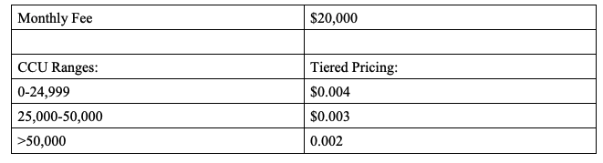

* + For opt-in / BTs that have multiple options, process every option as it’s own BT
    - The merchant will later delete which option wasn’t chosen
  + Process support fees
    - Some can be tiered unit BTs if there is a monthly allotment

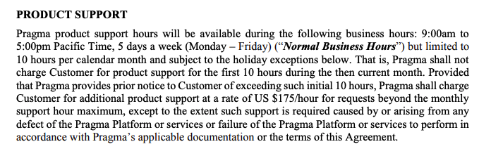

* + - This would be a tier unit BT monthly in arrears because the 10 hour allotment is given monthly
    - Make sure to double check if support fees are already bundled into the monthly platform fee
* **Discounts**
  + Process as negative BTs
* **Ignore:**
  + Ignore any "Wind Down Pricing" or fallback pricing.
  + Ignore any Revenue Sharing
    - Sometime there will be “Usage Fee” that are contingent on a customer exceeding a revenue threshold - do not process these usage fees either
      * Example: Usage Fees. If Customer has exceeded the Web3 Threshold, Customer will pay Pragma usage fees based on a tiered pricing schedule as set forth below. Fees start at $0.002 per concurrent user each hour, calculated by measuring the total number of users that access the
      * Web3 Threshold in this example is Web3 rev being 20% of product revenue
  + Do not enter BTs for "Pass Through Fees" unless a base or fixed component is defined.

1. Specifics processing things the merchant has requested that may differ by contract (e.g. always back-date invoice date to final day of the month)
2. Default Service Term
   1. If None Listed, Ops Default is 1 Year
3. Default Billing Frequency
   1. If None Listed, Ops Default is Monthly
4. How do we handle taxes as a line item?
   1. If None Listed, Ops Default is every tax line item becomes a BT

### Events Processing (if necessary) *(Entire Section: Implementation/Success to fill Post-Go Live)*

* Any important information on events billing

Integration Items Processing (if necessary)  
*(Entire Section: Implementation/Success to fill Post-Go Live)*

* Match the item name with the integration item.
  + If the match isn’t clear, continue processing but note to US team.

Post Processing Communications (if necessary)  
*(Entire Section: Implementation/Success to fill Post-Go Live)*

* Does the Ops Team need to notify anyone on the team re: completion of processing batches in Implementation or Active phase?
* Who needs to be notified and when?
  + Example:
    - Who: Customer Success [Azmat Aziz] needs to be notified
    - Where: Messari internal merchant channel
    - When: contracts are processed [Merchant Phase: Active]

### Customer Information *(Entire Section: Implementation/Success to fill Post-Go Live)*

* Any important information on specifics customers of this merchant
  + Special memo’s certain invoices require
  + Invoice changes due to merchant/customer relationship

### Feature Requests *(AE to fill for all requests prior to Imp handoff, Imp to fill prior to go-live/Success to fill to fill Post-Go Live)*

NA

### Merchant Calls *(AE to fill for all videos prior to Imp involvement, Imp to fill prior to go-live/Success to fill to fill Post-Go Live)*

* All gong calls in slack